Exploring the Chemical Reactions and Quantitative Relationships in the Production of a **Delicious Double Layer Chocolate Cake**

‘Stoichiometry and Cooking’

Owen Brake

2018/05/05

SCH3UR-C

Saxena

Contents

Introduction 2

Hypothesis 2

Materials 2

Observations 3

Chemical Formulas 4

Calculations: 4

Equation 7

Procedure 7

Pictures of Cooking Process 8

Analysis 9

Applications of Stoichiometry 10

Conclusion 12

References 13

# Introduction

Stoichiometry makes use of the relationships between mass and amount of the reactants and products in a chemical reaction. The amount of products in a chemical reaction can be predicted from the number of reactants. Stoichiometry problems involving masses can be solved by converting masses to amounts, using mole ratios. In this task you will relate stoichiometry with the everyday phenomena of cooking.

# Hypothesis

The reaction of an appropriate amount of sugar, flour, cocoa powder, baking powder, baking soda, salt, espresso powder, buttermilk, canola oil, eggs, vanilla extract and water should combine to create a delicious dough for a cake. While a combination of butter, cocoa powder, milk, vanilla extract and icing sugar should create a delicious icing. When these all react and mix with each other there should be little to no excess reactants and the mass of the ingredients should equal the mass of the products or exactly 2049g.

# Materials

1. 2 cups (278 grams) of all-purpose flour
2. 2 cups (380 grams) of granulated white sugar
3. 1 ¼ cup (113 grams) of unsweetened cocoa powder
4. 2 teaspoons (12 grams) of baking powder
5. 1 ½ teaspoons (9 grams) of baking soda
6. 1 teaspoon (3 grams) of salt
7. 1 teaspoon (2 grams) espresso powder
8. 1 cup (206 grams) buttermilk
9. ½ cup (111 grams) vegetable oil
10. 2 large eggs (128 grams)
11. 3 teaspoons (10 grams) vanilla extract
12. 1 cup (189 grams) boiling water
13. ¼ cup (72 grams) butter
14. ⅓ cup (50 grams) milk
15. 4 ½ cup (486 grams) confectioners’ sugar
16. Two 9 inch diameter pans
17. 1 pair of Oven Mitts
18. 1 Oven that can reach 350oF
19. 1 electric mixer
20. 2 large bowls
21. 1 small bowl
22. 1 microwave
23. 1 butter knife
24. 1 large serrated knife
25. 1 refrigerator
26. 1 teaspoon
27. 1 measuring cup
28. 1 table spoon
29. 2 large plates
30. 1 small pot
31. 1 stove top
32. 1 scale in grams

# Observations

|  |  |  |  |
| --- | --- | --- | --- |
| Substance | Before | During | After |
| Cake | As can be see in Figure 2. the batter for the cake is somewhat viscous while still remaining liquid. The mixture has a brown color and has some small particles of white flour. Chocolate can be detected by smelling however it is very light. | During cooking the batter started to rise within the pan. The batter turned from a liquid into a solid as can be seen in Figure 4. Where it is still in a liquid but is taking form. The batter became a darker color of brown. | The cake was a full solid, was a very dark brown color as can be seen in Figure 3. The cake was solid however when it was being touched it felt very spongy and moist. The cake came out of the oven very hot and it had clearly absorbed a significant amount of heat. The cake smells very good and smells like a chocolate muffin |
| Icing | The icing began as a collection of dry ingredients before the milk and icing sugar are added. The bowl is a light brown color and it appears very uniform. The mixture is very light and there is no smell. | As milk and icing sugar are added the substance becomes to appear like a liquid and it is clear that the substance is becoming heavier. | After all the icing sugar and milk is added the substance appears viscous yet still very much a liquid. The substance is a dark brown. |

Table 1. Qualitative observations of the chocolate cake base and its icing

|  |  |
| --- | --- |
| Substance | Mass(grams) |
| Flour | 278 |
| Sugar | 380 |
| Cocoa Powder | 113 |
| Baking Powder | 12 |
| Baking Soda | 9 |
| Salt | 3 |
| Espresso Powder | 2 |
| Buttermilk | 206 |
| Canola oil | 111 |
| Eggs | 128 |
| Vanilla Extract | 10 |
| Butter | 72 |
| Milk | 50 |
| Icing Sugar | 486 |
| Water | 189 |
| Final Measured Mass of Cake | 1923 |

Table 2. Quantitative Observations

# Chemical Formulas

* Flour
  + C4H8O4
* White Sugar
  + C12H22O11
* Cocoa
  + C4H8O4
* Baking Powder
  + NaHCO3
* Baking Soda
  + NaHCO3
* Salt
  + NaCl
* Espresso Powder
  + Trigonelline
    - C7H7NO2
* Buttermilk
  + Diacetyl
    - C4H6O2
* Vegetable Oil
  + C3H8O3
* Egg
  + C6H12O3N2
* Vanilla Extract
  + C8H8O3
* Water
  + H2O
* Butter
  + C9H14O6
* Milk
  + 85% H2O
  + 15% C9H14O6
* Icing sugar
  + C12H22O11

# Calculations:

Moles = mass/molar mass

n=m/M

Finding the moles for each substance

nFlour = 278/(4*12.01+8*1.01+4*16.00)

=2.314

=2.31 mol of flour

nSugar=380/(12*12.01+22*1.01+11*16.00)

=1.110

=1.1 mol of sugar

nCocoa=(60g+53g)/(4*12.01+8*1.01+4*16.00)

=0.9407

=0.94 mol of cocoa powder

nBaking Powder=12/(22.99+1.01+12.01+16.00*3)

=0.1428

=0.14 mol of baking powder

nBaking Soda=9/(22.99+1.01+12.01+16.00*3)

=0.1071

=0.1 mol of baking soda

nSalt=3/(22.99+35.45)

=0.05133

=0.05 mol of salt

nEspresso powder=2/(7*12.01+7*1.01+14.00+2*16.00)

=0.01458

=0.01 mol of espresso powder

nButtermilk=206/(4*12.01+6*1.01+2*16.00)

=2.392

=2.39 mol of buttermilk

nVegetable Oil = 111/(3*12.01+8*1.01+3*16.00)

=1.205

=1.20 mol of vegetable oil

nEgg=128/(6*12.01+12*1.01+3*16.00+2*14.00)

0.7991

0.799 mol of egg

nvanilla=(7g+3g)/(8*12.01+8*1.01+3*16.00)

=0.0657

=0.07 mol of vanilla extract

nWater=189/(2*1.01+16.00)

=10.48

=10.5 mol of water

nButter = 72g/(9 * 12.01 + 14 * 1.01 + 6 * 16.00)

=0.3299

=0.33 mol of butter

nMilk = nH2O + nC9H14O6

nH2O =(50*0.85)/(2*1.01+16.00)

=2.358 mol

nC9H14O6 = (50*0.15)/(9*12.01+14*1.01+6*16.00)

=0.03436 mol

=2.358+0.03436

=2.392

=2.4 mol of milk

nIcing Sugar= 486g/(12*12.01+22*1.01+11*16.00)

=1.4196

=1.42 mol of icing sugar

Efficiency of Reaction

Measured mass / theoretical mass = efficiency %

(1923g / 2049g) * 100% = 93.85%

Formula for the cake

C4H8O4 + C12H22O11 + C4H8O4 + NaHCO3 + NaHCO3 + NaCl + C7H7NO2 + C4H6O2 + C6H12O3N2 + C8H8O3 + C3H8O3 + H2O-> Cake

Formula for the Icing

C9H14O6 + (C4H8O4+ H2O) + C9H14O6 + C8H8O3  + C12H22O11 -> Icing

Combined Formula

2.31C4H8O4 + 1.1C12H22O11 + 0.94C4H8O4 + 0.14NaHCO3 + 0.1NaHCO3 + 0.05NaCl + 0.01C7H7NO2 + 2.39C4H6O2 + 0.799C6H12O3N2 + 0.07C8H8O3 + 1.20C3H8O3 + 10.5H2O + 2.358C9H14O6 + 0.03436H2O+ 1.42C12H22O11 -> Iced Cake

Adding the common coefficients up

3.25C4H8O4 +2.52C12H22O11 + 0.24NaHCO3 + 0.05NaCl + 0.01C7H7NO2 + 2.39C4H6O2 + 0.799C6H12O3N2 + 0.07C8H8O3 + 1.20C3H8O3 + 10.5H2O + 2.358C9H14O6 -> Iced Cake

Converting the mols to coefficients for the final balanced equation

|  |  |  |  |  |  |  |  |  |  |  |
| --- | --- | --- | --- | --- | --- | --- | --- | --- | --- | --- |
| C4H8O4 | C12H22O11 | NaHCO3 | NaCl | C7H7NO2 | C4H6O2 | C6H12O3N2 | C8H8O3 | C3H8O3 | H2O | C9H14O6 |
| 3.25mol | 2.52mol | 0.24mol | 0.05mol | 0.01mol | 3.066mol | 0.799mol | 0.07mol | 1.20mol | 10.5mol | 2.358mol |
| Divide | Divide | Divide | Divide | Divide | Divide | Divide | Divide | Divide | Divide | Divide |
| 0.01mol | 0.01mol | 0.01mol | 0.01mol | 0.01mol | 0.01mol | 0.01mol | 0.01mol | 0.01mol | 0.01mol | 0.01mol |
| Equals | Equals | Equals | Equals | Equals | Equals | Equals | Equals | Equals | Equals | Equals |
| 325mol | 252mol | 24mol | 5mol | 1mol | 306.6mol | 79.9mol | 7mol | 120mol | 105mol | 236 mol |
| Multiply | Multiply | Multiply | Multiply | Multiply | Multiply | Multiply | Multiply | Multiply | Multiply | Multiply |
| 3 | 3 | 3 | 3 | 3 | 3 | 3 | 3 | 3 | 3 | 3 |
| Equals | Equals | Equals | Equals | Equals | Equals | Equals | Equals | Equals | Equals | Equals |
| 975mol | 756mol | 72mol | 15mol | 3mol | 920mol | 240mol | 21mol | 360mol | 315mol | 708mol |

# Equation

975C4H8O4 + 756C12H22O11 + 72NaHCO3 + 15NaCl + 3C7H7NO2 + 920C4H6O2 + 240C6H12O3N2 + 21C8H8O3 + 360C3H8O3 + 315H2O + 708C9H14O6 🡪 Iced Cake

# Procedure

1. Gather Materials
2. Preheat oven to 350oF.
3. Grease two 9 inch diameter pans with less then 1 tbsp of butter and less then 1 tbsp of flour
4. Pour 2 cups of Flour, 2 cups of white sugar, ¾ cup of cocoa powder, 2 teaspoons of Baking Powder, 1 ½ teaspoons of Baking Soda, 1 teaspoon of Salt and 1 teaspoon of Espresso Powder into a large bowl
5. Mix the ingredients with the electric mixer on medium until the ingredients appear uniform
6. Pour 1 cup of Buttermilk, ½ cup of Vegetable Oil, 2 large Eggs and 2 teaspoons of Vanilla Extract into the mixture of solid ingredients
7. Mix the large bowl in the electric mixer with the mixer on low
8. Boil 1 cup of water on the stove top while wearing oven mitts
9. Slowly add 1 cup of boiling water while mixing on low.
10. Remove the mixture from the electric mixer
11. Evenly distribute the resulting mixture into the two 9 inch pans.
12. Place the two pans in the oven while wearing oven mitts and cook for 35 minutes
13. Remove the two pans from the oven while wearing oven mitts after 35 minutes and leave to cool for 15 minutes
14. Remove the cakes from the pans after 15 minutes and place on two large plates
15. Put ¼ cup of butter into a small bowl
16. Put the bowl of butter into the microwave for 30 seconds or until melted
17. In a large, clean bowl pour ¼ cup of melted butter and ½ cup of cocoa powder
18. Put the bowl in the electric mixer and mix on medium until uniform
19. Pour 1/3 cup of milk and 1 teaspoon of vanilla extract into the mixture.
20. Mix on medium until uniform
21. Continue to mix on low while slowly adding 4 ½ cups of icing sugar
22. Mix on medium until the icing sugar is properly mixed
23. Refrigerate the icing for 30 minutes
24. Take the two solid cakes and cut off the top of one of them with a large serrated knife
25. Spread the icing from the bowl onto the cake with the cut top using a butter knife,
26. Placed the second cake from the other pan onto the iced one
27. Apply the remaining icing on the entire cake using a butter knife
28. Refrigerate cake for 25 minutes
29. Record Observations
30. Dispose of materials and clean work station
31. Serve cake.

# Pictures of Cooking Process

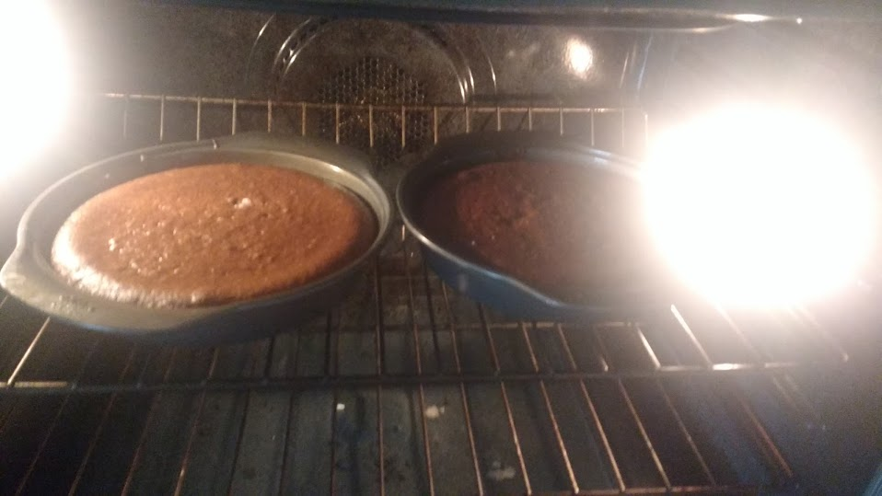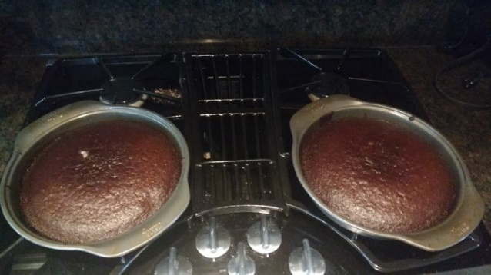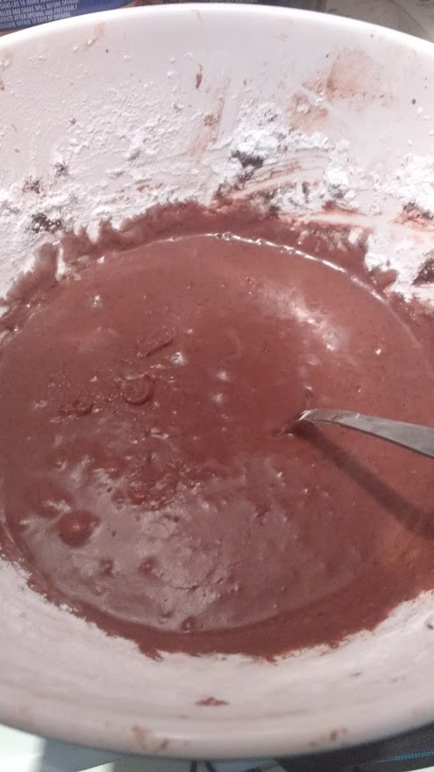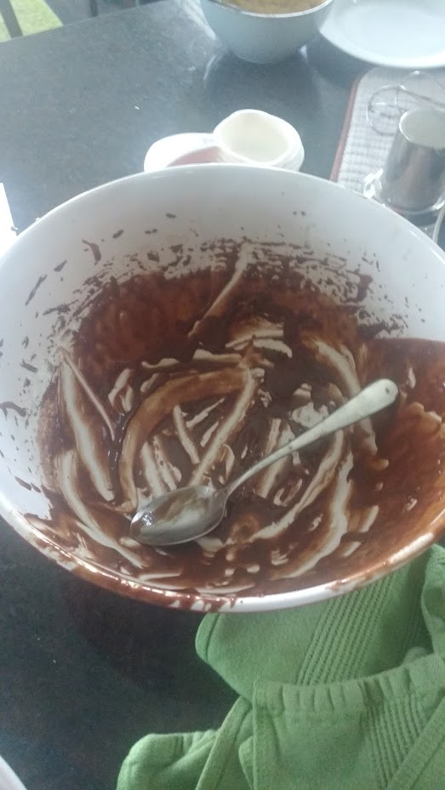

Figure 4 Rising Cake Batter

Figure 3 Finished Cake Batter

Figure 2 Bowl full of Batter

Figure Remaining Cake batter

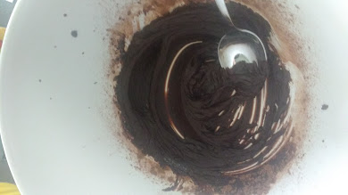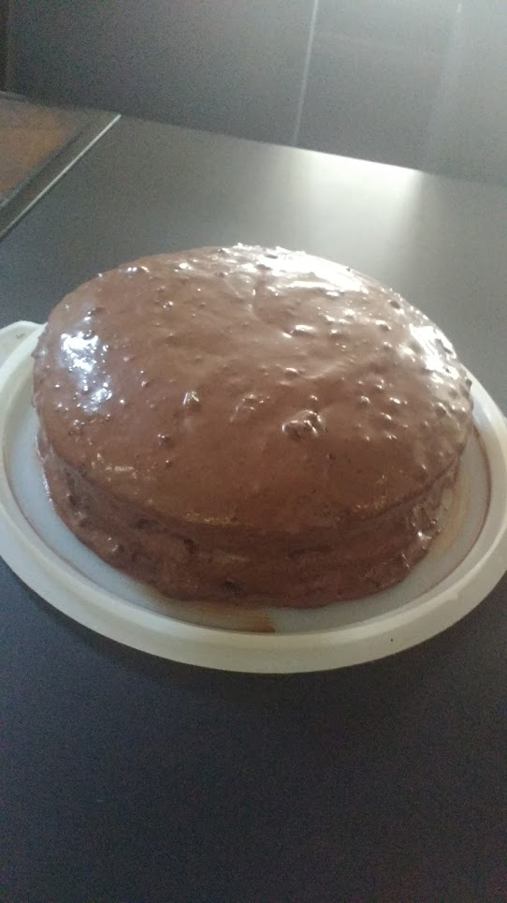

Figure 6 Icing in bowl

Figure 5 Finished Iced Cake

# Analysis

The results were as expected, when the proper procedure was followed, a delicious cake was produced that met much of the hypothesis’s requirements. There were no visible excess reactants, all of the ingredients were able to mix properly and fully into the cake. This establishes that the equation “975C4H8O4 + 756C12H22O11 + 72NaHCO3 + 15NaCl + 3C7H7NO2 + 920C4H6O2 + 240C6H12O3N2 + 21C8H8O3 + 360C3H8O3 + 315H2O + 708C9H14O6 🡪 Iced Cake” is the ideal equation where there are no excess reactants. The lack of any identifiable excess reactants is most likely due to the baking process itself. When the cake batter is placed in the oven it most likely has excess reactants as the bowl may not have been fully mixed. The baking process removes these potential impurities, for some excess reactants they are evaporated or they turn into a gas and escape the cake while for others they fuse into the cake. Some of the excess reactants may have simply been baked with the cake and thus got put into the cake while in the batter it was not fully mixed in. The first part of the hypothesis was correct there were no excess reactions however the second part of the hypothesis did not completely match the observations.

There was however an anomaly, when the cake was finally massed it was found to be 1923 grams, not the 2049 grams as predicted and as is followed by the law of conservation of mass. That is a 126 grams of ingredients, how can this be accounted for? There are many possible reasons that so much mass could be lost in a cake. The first and most probable answer is due to the nature of baking, when an object undergoes baking it is subject to high temperatures and the temperate that the batter was baked at was 350oF or 177oC which is above the boiling point of water. This would mean that while the batter is baking and turning into a solid object, some of the liquid is evaporating and boiling up. This would explain a part of the loss in mass but that cannot be the only reason, another very possible reason is due to what is visible in Figure 1, a large amount of the batter is still inside the bowl, and this was the same case for the icing. The remaining batter could not be removed as the batter was fairly viscous and would tend to stick to the sides of the bowl. Finally there is another possible source of error and that is visible in Figure 2. In Figure 2. It can be seen that there is flour residue on the side of the bowl this is due to the whisking of the ingredients using the electric mixer which caused some ingredients to fly out this means some mass was lost as it never entered the mixture it like the flour was shot outwards. Another though rare possibility however is the idea that the ingredients would bond with the other elements. Especially with the more reactive elements it does not become an impossible idea that potentially some of the ingredients bonded with external forces such as oxygen, nitrogen or carbon dioxide. Despite all these sources of the result is not actually surprising, the reaction had a calculated 93.85% which is not bad considering that there was no balanced equation that could be made so the values for the ingredients had to be estimated without any data.

# Applications of Stoichiometry

One application of stoichiometry is in the pharmaceutical business. When calculating the dosage for a pill or the number of compounds to put inside of one. Chemists cannot simply use the SI unit grams as a measurement as they are impractical and difficult to use, chemists will use mols and stoichiometry to discover. Chemists cannot use grams as if they were to change the chemical or one atom within a single compound it would fundamentally alter all the calculations as the molar mass would be different while when using mols anyone can swap out any compound with another as everything is measured in mols and mols is the number of particles rather than mass. Chemists in pharmaceutical companies will constantly be using stoichiometry, they will use stoichiometry to determine how many excess reactants are left over and calculating the right number of mols of a substance so that there is very little excess in consumption. They must calculate how the medicine will react with the body and use stochiometric calculations to determine how much medicine is entering the blood stream and whether that medicine will be effective or not. The scientists must alter the dosages to match there calculations so that the patient does not overdose while the patient still receives the positive effects of the drug.

Application in Carbon Dioxide Removal in Space

In space carbon dioxide becomes a major issue for long term stays, so how does one remove carbon dioxide from the air system in space. Carbon dioxide is a dangerous gas in high quantities and becomes lethal, if excess carbon dioxide is not removed from the air system then the astronauts on board would suffocate as they would lack any breathable air and would be intaking carbon dioxide instead of oxygen. Scientists were able to discover away using stoichiometry and chemical reactions to properly deal with excess carbon dioxide. These scientists use canisters of lithium hydroxide, the lithium hydroxide will absorb carbon dioxide and react with it to produce lithium carbonate. This lithium carbonate is a solid and is a lot easier to dispose of then carbon dioxide gas and is not lethal. These canisters however are disposable so they lithium hydroxide eventually becomes used up and the canister is filled with lithium carbonate. These canisters must be replaced from canisters from earth and the quantity of lithium hydroxide must be calculated. Scientists will use stoichiometry to determine how much lithium hydroxide must be replaced so that enough carbon dioxide is absorbed and so that the lithium hydroxide will last long enough. The scientists will use the balanced chemical formula and then calculate the amount of lithium hydroxide to remove this amount of carbon dioxide using stoichiometry. Without these stochiometric calculations then the astronauts would suffocate as the scientists would not know how much lithium hydroxide would need to be put on these space stations.

Application in Battery Production

A large growing industry today is battery production as with the growing spread of renewable energy there needs to be some way of storing it so these chemists have to produce the correct amount of substances and chemical to put inside of their batteries. These chemists must use stoichiometry to determine how much of a substance will this reaction produce, will this chemical react with this chemical to produce a better, longer battery span? Chemists have to experiment with these ideas and produce their own battery utilizing a number of factors. One of these factors is excess reactants, batteries have become highly complex and efficient so to improve the efficiency further once must have little to no waste as this is a waste of energy. The battery manufacturers and designers must plan so that these battery acids do work at their best efficiency and there are no excess reactants produced to hinder the effects of the battery. An example of stoichiometry in battery production is the doping of materials such as silicon, scientists will modify the oxidation state of such materials to produce different properties such as changing from p type to n type silicon. This requires significant knowledge of stoichiometry because scientists must mix and calculate the precise values and products of a reaction to get the perfect properties for the material.

Application in Motor Vehicles

Many motor vehicles today rely on hydrocarbons most commonly petrol. These fuels are pumped into the gas tank and then are pump into the combustion engine when needed. The combustion engine acts like a combustion reaction and burns the fuel with oxygen to produce energy. There however is a limiting reagent, oxygen, these combustion engines often lack enough oxygen which produces incomplete combustion and the excess fuel will return out the exhaust. This incomplete combustion is not only dangerous but is a significant waste of fuel as a varying amount will be driven out of the exhaust as excess. To prevent this from occurring engineers must find the exact ratio of how much oxygen is pumped in against how much fuel is taken in. If there is too much fuel and not enough air then excess fuel was will be lost while if there is too much air it may cause the combustion engine to do too much work to create the same amount of energy as there is a greater volume to heat. Engineers will calculate this fuel to air ratio using stochiometric calculations, they will find the mass of the fuel going into the engine and compare that against the mass of the air being let in, once it is compared with the chemical formula these engineers must tweak their designs to limit or increase the amount of air being let in. Different fuels will have different fuel to air ratios, natural gas requires 17.2 kg of oxygen for every kg of fuel while methanol only requires 6.4 kg of oxygen for every 1kg of fuel. It is apparent that methanol is the more efficient fuel and thus can burn with less oxygen resulting in the engine being able to burn properly without extensive measures to ensure complete combustion.

# Conclusion

This lab involved baking a cake and using the mass of the ingredients and the products to determine the validity of stochiometric calculations and verifying the properties that exist in the theoretical field. The participants must find the mols of each ingredient using approximations of chemical formulas to manufacture a molecular formula and determine the efficiency of the reaction. This experiment was ultimately a success. There were very few to no excess reactants found within the cake however the mass of the products was slightly less then the mass of the reactants an anomaly which has a multitude of possible answers but ultimately acts as a lesson that the theoretical world is not always a perfect indicator of the practical world. Though the hypothesis was not entirely accurate, this was a great learning experience and provided a real-world application of a science which often lacks the ability to represent its applications. Hopefully this lab can further prove stoichiometry’s usefulness and apparent ubiquity in the world while also providing a learning function for other students. Through the baking of a delicious cake any individual can access the complex sciences of chemistry and stoichiometry.

# References

Burggraaf, W. (2017, January 03). Buttermilk. Retrieved May 1, 2018, from

<https://www.safefoodfactory.com/en/knowledge/38-buttermilk/>

Goel, T. (2013, August 01). How to Calculate the Stoichiometric Air-fuel Ratio (L. Stonecypher,

Ed.). Retrieved May 5, 2018, from <https://www.brighthubengineering.com/machine->design/15235-the-stoichiometric-air-fuel-ratio/

Kamarulzaman, N., & Hilmi, M. (2012). Synthesis and Stoichiometric Analysis of a Li-Ion

Battery Cathode Material. Stoichiometry and Materials Science - When Numbers Matter, 247-262. doi:10.5772/33189

Matty, C. (2010). Overview of Carbon Dioxide Control Issues During International Space

Station/Space Shuttle Joint Docked Operations. 40th International Conference on Environmental Systems, 1-9. doi:10.2514/6.2010-6251

Roth, K., Prof. (2003). Espresso – A Three-Step Preparation. Retrieved from

[http://www.chemistryviews.org/details/ezine/694285/Espresso__A_Three-Step_Preparati](http://www.chemistryviews.org/details/ezine/694285/Espresso__A_Three-Step_Preparation.html)

[on.html](http://www.chemistryviews.org/details/ezine/694285/Espresso__A_Three-Step_Preparation.html)

Stone, R. (2018, April 20). The Best Chocolate Cake Recipe {Ever} - Cooking. Retrieved May

1, 2018, from https://addapinch.com/the-best-chocolate-cake-recipe-ever/

Sucrose. (n.d.). Retrieved May 2, 2018, from

https://pubchem.ncbi.nlm.nih.gov/compound/sucrose#section=Top

T. (2008, March 03). Chocolate Frosting I Recipe. Retrieved May 1, 2018, from

https://www.allrecipes.com/recipe/25563/chocolate-frosting-i/